**Client Terms of Engagement – between OCC Housing and ODS**

**Appendix x**

1. **Relationship between OCC Housing and ODS**

The housing division is the Local Housing Authority for Oxford City Council, and through which it exercises its landlord responsibilities for the Housing Revenue Account (HRA), tenants and leaseholders.

The overarching strategic arrangements agreed between the Council (Oxford City Council and the Contractor (Oxford Direct Services Ltd) are framed within the Memorandum of Understanding approved by the Council’s City Executive Board on the 21st Nov 2017 and the Service Agreement agreed on the 24th May, 2018. Together, these set out the overarching principles, purpose and governance arrangements for the delivery of Services by ODSL to and on behalf of the Council. These arrangements include delivery of works and services to tenants and leaseholders living in council housing assets.

This document therefore stems from these wider arrangements and sets out the client/provider operating practice and obligations to be followed by both parties. This procedure complements the Commissioning of Works document and identifies practical arrangements for the delivery of the commissioning of the 5 Year Investment Programme plan (2025/26 – 2029/30)

1. **Administration and governance**

The lead OCC Housing client-side Chief Officer representation will be the Head (Director) of Housing and/or their nominee(s). The lead for ODS officer representation will be the Chief Operating Officer and any nominee(s) as desired.

There will be two levels of client management meetings (1) Strategic and (2) Operational. This is to ensure that both parties are working to common corporate objectives, delivery of services and any changes which may arise within the OCC Housing as a result of political and policy changes within the council. The governance / monitoring framework arrangements will comprise of :

* Two monthly operational meetings – one for demand led works – eg; responsive repairs and another for planned works. These will be programmed in advance and take place in the second half of each calendar month.
* Strategic meetings – will take place quarterly. These will be programmed in advance and take place every three months [quarterly]
* Membership is subject to change by either party as and when required to meet service needs

**Strategic and quarterly liaison meetings**

Strategic quarterly meetings will take place with focus on more strategic matters related to the delivery of the 5 Year Programme Plan requirements and savings and wider strategic matters that may impact on the commissioning of services

The agenda for each meeting will comprise of standard items as well as items submitted with agendas circulated [at least 3 working days] in advance of meetings, with minutes and action points agreed at meetings and circulated within reasonable time after the meeting .

Standard agenda items may include – but not limited to:

* Strategic overview of 5 Year Programme delivery plan
* Changes to national, regional and council strategy and policy
* Requirements and changes from Housing Regulator and Housing Ombudsman requirements
* Impact of unforeseen events
* Tenant and leaseholders involvement and satisfaction and related *Transparency, Influence and Accountability Consumer Standard*
* Health and Safety – including; compliance and risk management and related *Safety and Quality Consumer Standard*

Strategic membership:

|  |  |
| --- | --- |
| OCC Housing representatives (Client) | ODS representatives (Provider) |
| ***To be Agreed – by OCC*** | ***To be agreed by ODS*** |

**Operational monthly meetings**

There will be two monthly agreed scheduled client-side meetings between OCC Housing and ODS to discuss performance monitoring, service delivery, business planning, health and safety and any other issues of concern to either party on a project area by project area basis relating to the 5 Year Programme Plan.

* One meeting will focus on monitoring delivery of demand led services – eg; responsive repairs etc
* the second will focus on monitoring delivery of Planned works
* Meetings will be Chaired by the client and will be attended by officers from OCC Housing/Corporate Property and ODS who are leads on programme areas
* The agenda for each meeting will comprise of standard items *[see below]* as well as any other items requested by both parties
* Agendas will be circulated [at least 3 working days] in advance of meetings, with minutes and action points agreed at meetings and circulated within reasonable time after the meeting

**Standard agenda items can include – but not limited to :**

* Progress against delivery of the Service Specification as per *Appendix [x]* for ODS
* Progress against delivery of efficiency savings targets as agreed between ODS/OCC
* Constraints, revisions and updates of the ODS Delivery Plan
* Project specification reviews
* Performance monitoring including achievement against the key performance indicators to be developed during the transitional – Year 1
* Procurement and contract management issues/activities
* Feedback on any issues relating to tenants, leaseholders and sheltered groups in the delivery of programme works
* Management of complaints & members enquiries
* Financial information - actual and projected expenditure against the HRA planned/demand led budgets including delivery of any efficiency targets agreed during transition period Year 1
* Sharing of asset management information throughout projects
* Management reports requested by the Client
* Health & Safety including compliance and risk management

**Operational membership of monthly meetings:**

|  |  |
| --- | --- |
| OCC Housing representatives (Client) | ODS representatives (Provider) |
| ***TBC*** | ***TBC*** |

**Facilitating the annual cycle review and planning process ;**

* OCC Housing as the client and ODS will carry out an annual review of performance and delivery as per the service specification arrangements every October. A timetable is provided below which seeks to coincide with the end of financial year Council’s budget setting and Housing Revenue Account (HRA) business planning taking place in February every year.
* The annual agreement review will need to dovetail with the Council’s annual business cycle planning. This means that the OCC Housing as the client will need to issue an annual revised 5 Year Programme Plan by August every year so that ODS is able to consider and develop a Business Delivery Plan of how it proposes to deliver for the relevant year and achieve the savings targets agreed. It will seek to do during the month of October. In the event of any amendments being required which may stem from discussions with OCC Housing – a final agreed draft will need to be issued to OCC Housing by November at the very latest to ensure it meets is budgetary business cycle.
* Prior to the annual meeting – ODS will be required to submit a final draft of the Business Delivery and efficiency savings Plan – 2 weeks in advance of the scheduled meeting
* A review group Chaired by the Head [Director] of Housing and consisting of nominated Client/Provider officers will seek to jointly review the Business Delivery Plan and planned work for the year ahead

|  |  |  |
| --- | --- | --- |
| **Task** | **Responsibility** | **Deadline** |
| Client to issue the Provider following financial year commissioning including Service Specification | Client  (OCC Housing) | 31st August |
| Provider to issue the Client with a Business Delivery Plan (including annual review) | Provider  (ODS) | 30th Sept |
| Review and refine Business Delivery Plan following input from Client | Provider  (ODS) | 31st Oct |
| Issue to Client final Business Delivery Plan in advance of OCC Housing Annual Agreement Review Meeting | Provider  (ODS) | 1st Nov |
| Annual Agreement Review Meeting | Client/Provider  OCC Housing/ODS) | Mid Nov |

**ODS / Business Delivery Plan**

Each year in October, in consultation with the OCC Housing/Corporate Property – client team, ODS will submit a Business Delivery Plan with the purpose of outlining how it intends to deliver the annual programme of works, service specifications and annual agreed savings.

The Plan will be expected to include the following;

**Service performance review :**

* Review of key achievements, improvements and progress in the previous 12months against the service specification provided OCC Housing – client
* Benchmarking – information on how the ODS as the Provider, performance compares with other similar organisations – to evidence value for money
* Review of contribution to corporate objectives including social value

**Planning**

* Objectives and priorities for the forthcoming 12 months, including issues and challenges that ODS expects to face in the next 12 months that may impact on service delivery
* Outline of strategy for meeting key challenges, vision and delivery of financial efficiencies over the next 12 months
* Outline of strategy to demonstrate how the council’s corporate objectives are being met, including contributions to social value
* Summary of services that the Provider proposes to deliver in the next 12 months, having regard to the requirements of the Service Specification
* Planned procurement activity over the forthcoming 12 months
* Resource requirements and implications for the delivery of services over the next 12 months
* Arrangements for sub-contracting relationships
* Strategy for resident engagement and any leaseholder consultation

**Value for Money**

* Delivery of efficiencies and savings targets as agreed
* Unit cost of key services, as and when agreed
* Demonstration of how value for money is being achieved (types of work carried out)
* Plans to improve service delivery

**Budget and financial information**

* Income - projected with adjustments and broken down by key services
* Expenditure - projected with adjustments and broken down by key service and funding source e.g. works fee element of the HRA, capital programme
* Capital budgets (where applicable)

**Staff training and development needs**

* Skills gaps
* Restructures
* Absence and retention of staff
* Apprenticeships

**Risk Management**

* Register of risks

**Health and Safety and Compliance**

* Health and safety update
* Confirmation of adherence to all current statutory requirements, including but not limited to:
  + Health and Safety at Work Act 1974
  + The Control of Asbestos Regulations 2012
  + Construction Design and Management Regulations 2015
* Confirmation of adherence to the Council’s Health, Safety and Wellbeing Strategy and the Health and Safety Policy, and other Council policies

**Performance Dashboards**

* The two dashboards as agreed between the Client and Provider
* Headings of areas requiring performance data

**Action Plan**

Including business as usual and projects / programmes to implement improvements as commissioned by OCC Housing

OCC Housing will make relevant internal arrangement to consult and obtain approval/agreement of the Business Plan (e.g. via CMT / Cabinet as required ).

**Practical arrangements between OCC Housing -the Client and ODS the Provider**

ODS will work closely with OCC to ensure that it contributes to overall council housing policy and service delivery – in particular where these relate to Housing Regulator and Housing Ombudsman requirements. OCC Housing will be responsible for communicating any policy revisions to ODS so that these can be reflected, where appropriate, by the delivery plan and/or procedures and practices

The following are examples where cohesion between policy objectives, strategic direction and operational delivery will be essential;

* Health & safety – Housing regulator consumer standards
* Customer access and service standards
* Tenant and leaseholder participation
* Other corporate requirements e.g., IT systems

**Access to information**

Access to information is specified within the service specification for the purpose of audit and validation of works. ODS will deliver services to OCC Housing on an open-book basis. From time to time, OCC Housing will carry out visits as necessary to ODS offices and its sites. The focus of this activity will be but not limited to:

* Delivery of programmes including quality and financial information
* Validation of data
* Health and safety
* Tenant and leaseholder satisfaction

ODS is expected to cooperate fully with this process including access to relevant officers and documentation.

**Delivery of Council housing priorities and political arrangements**

The service specification provides a clear commitment to partnership working between OCC Housing - Client and ODS as the Provider. OCC Housing is responsible for developing the Council’s housing strategies (for eg:- HRA Business Planning, Asset Strategy and others) ensuring that housing activities contribute to the Council’s priorities and policy objectives. Policy issues can arise from national, regional and local issues. Any related impact, in particularly those that may have an impact on the commissioning of services will be communicated to ODS through the client management arrangement process.

**Cabinet and Scrutiny Committees**

The main items of business between OCC Housing and ODS will be on performance management and review of the delivery of the 5 Year Programme Plan and efficiency savings delivery. To facilitate this, ODS will upon request by OCC Housing provide performance information and comments to enable the preparation of reports on its activities and performance for the purposes of internal reporting and scrutiny. Where necessary ODS will arrange for the attendance of a representative to attend such meetings for accountability purposes and to report progress.

**END**

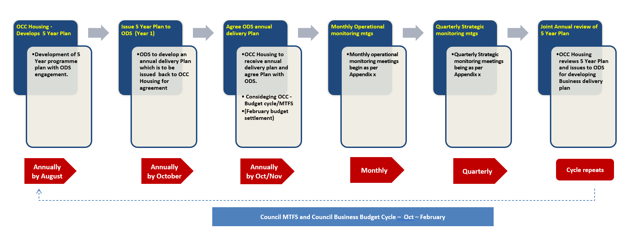**DRAFT - Overview – 5 Year Programme Plan – annual review process**